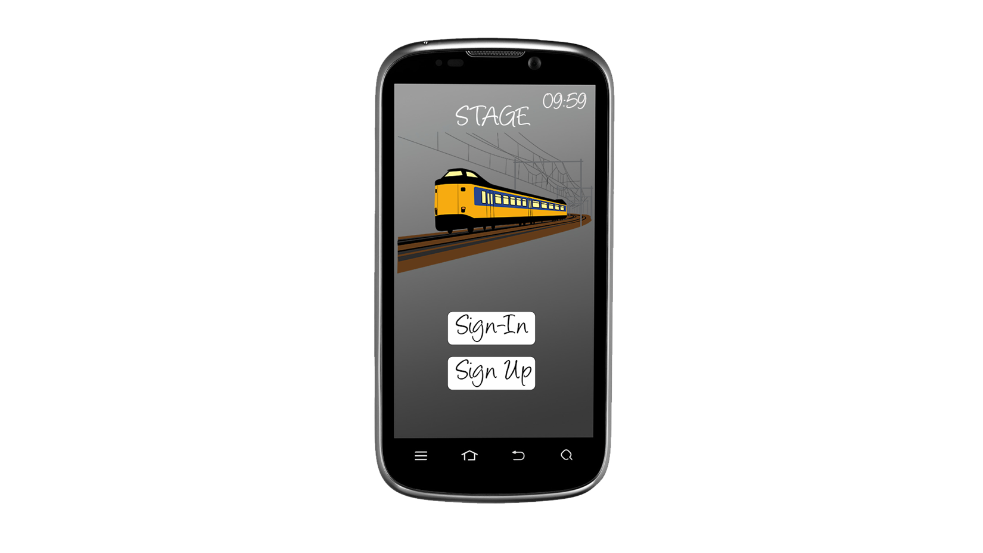S.T.A.G.E

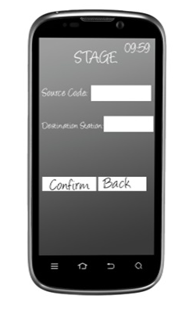**Proposed system**

The application is downloaded from the Google Play Store.

Every user must sign up by providing a Name and a Password.

User account is created using the user’s mobile number.

User’s mobile number serves as a unique ID for further process

such as login, database access, booking, retrieval etc.

A random code 10 digit code is generated uniquely for each station.

This code is refreshed periodically and it is entered as a

source station. The destination can be chosen from the list provided.

Simple algorithm is used to generate ticket by deducing the

amount from user database record. After booking, the ticket is displayed

in user’s screen with one hour validity after which it is expired.

Recharging is done at standard ticket counter. While recharging the user’s

mobile number is taken as primary key. The user database record is updated

with the recharged amount.

**Requirements**

Software

* Eclipse Integrated Development Environment (IDE)
* Android Development Tool(ADT)
* Software Development Kit(SDK)
* Android system image for Emulator

Hardware

* Laptop
* Microcontroller based LED display